**厂商平台优化实践**

**网络优化**

**HTTP2（done）**

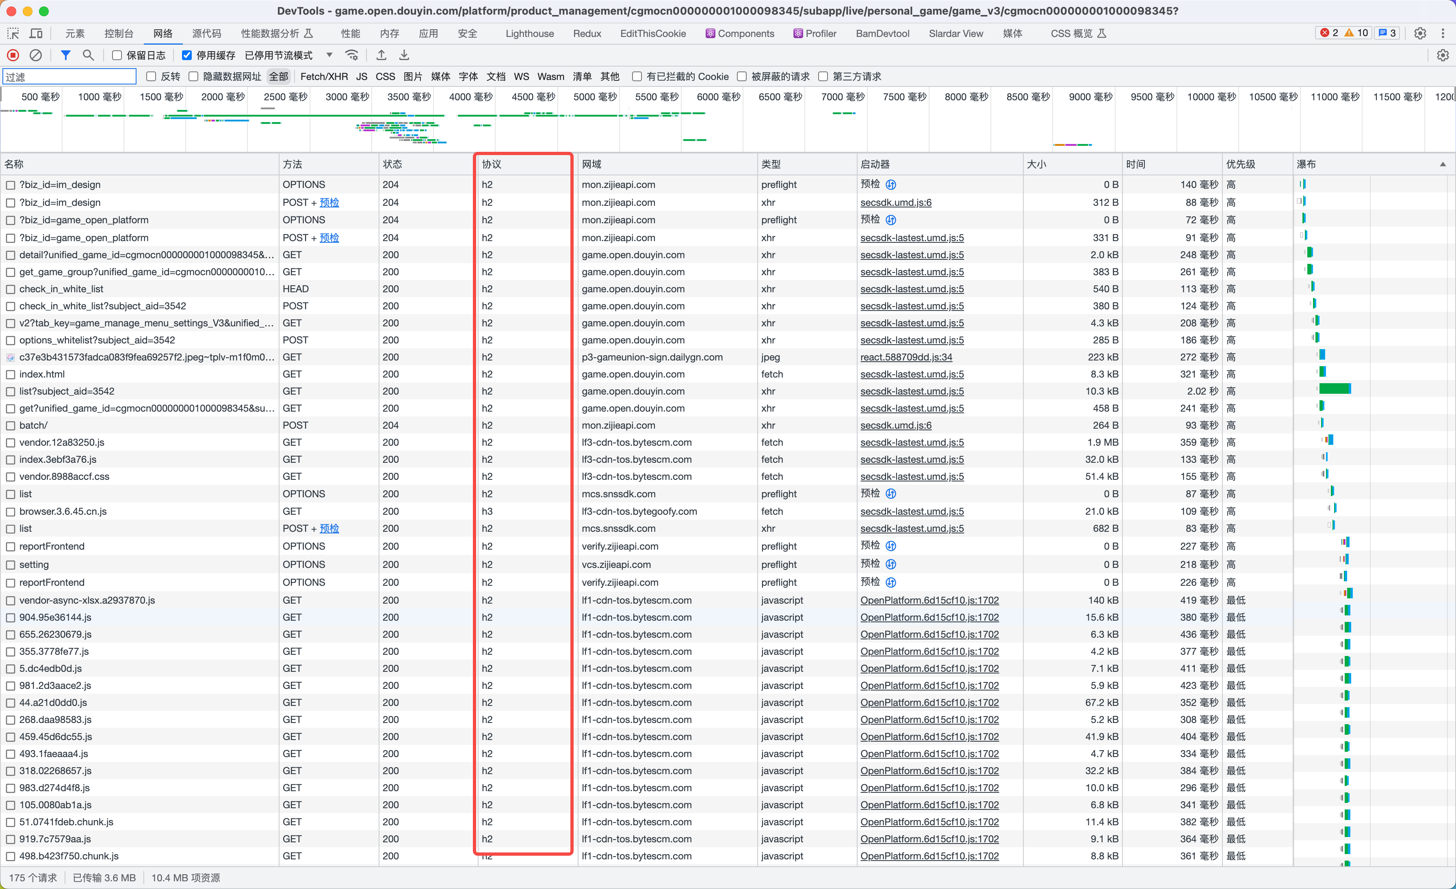

**开启 br 压缩（done）**

|  |
| --- |
| [psm 开启 br 压缩](https://site.bytedance.net/docs/5402/neptune/http_compress/) |

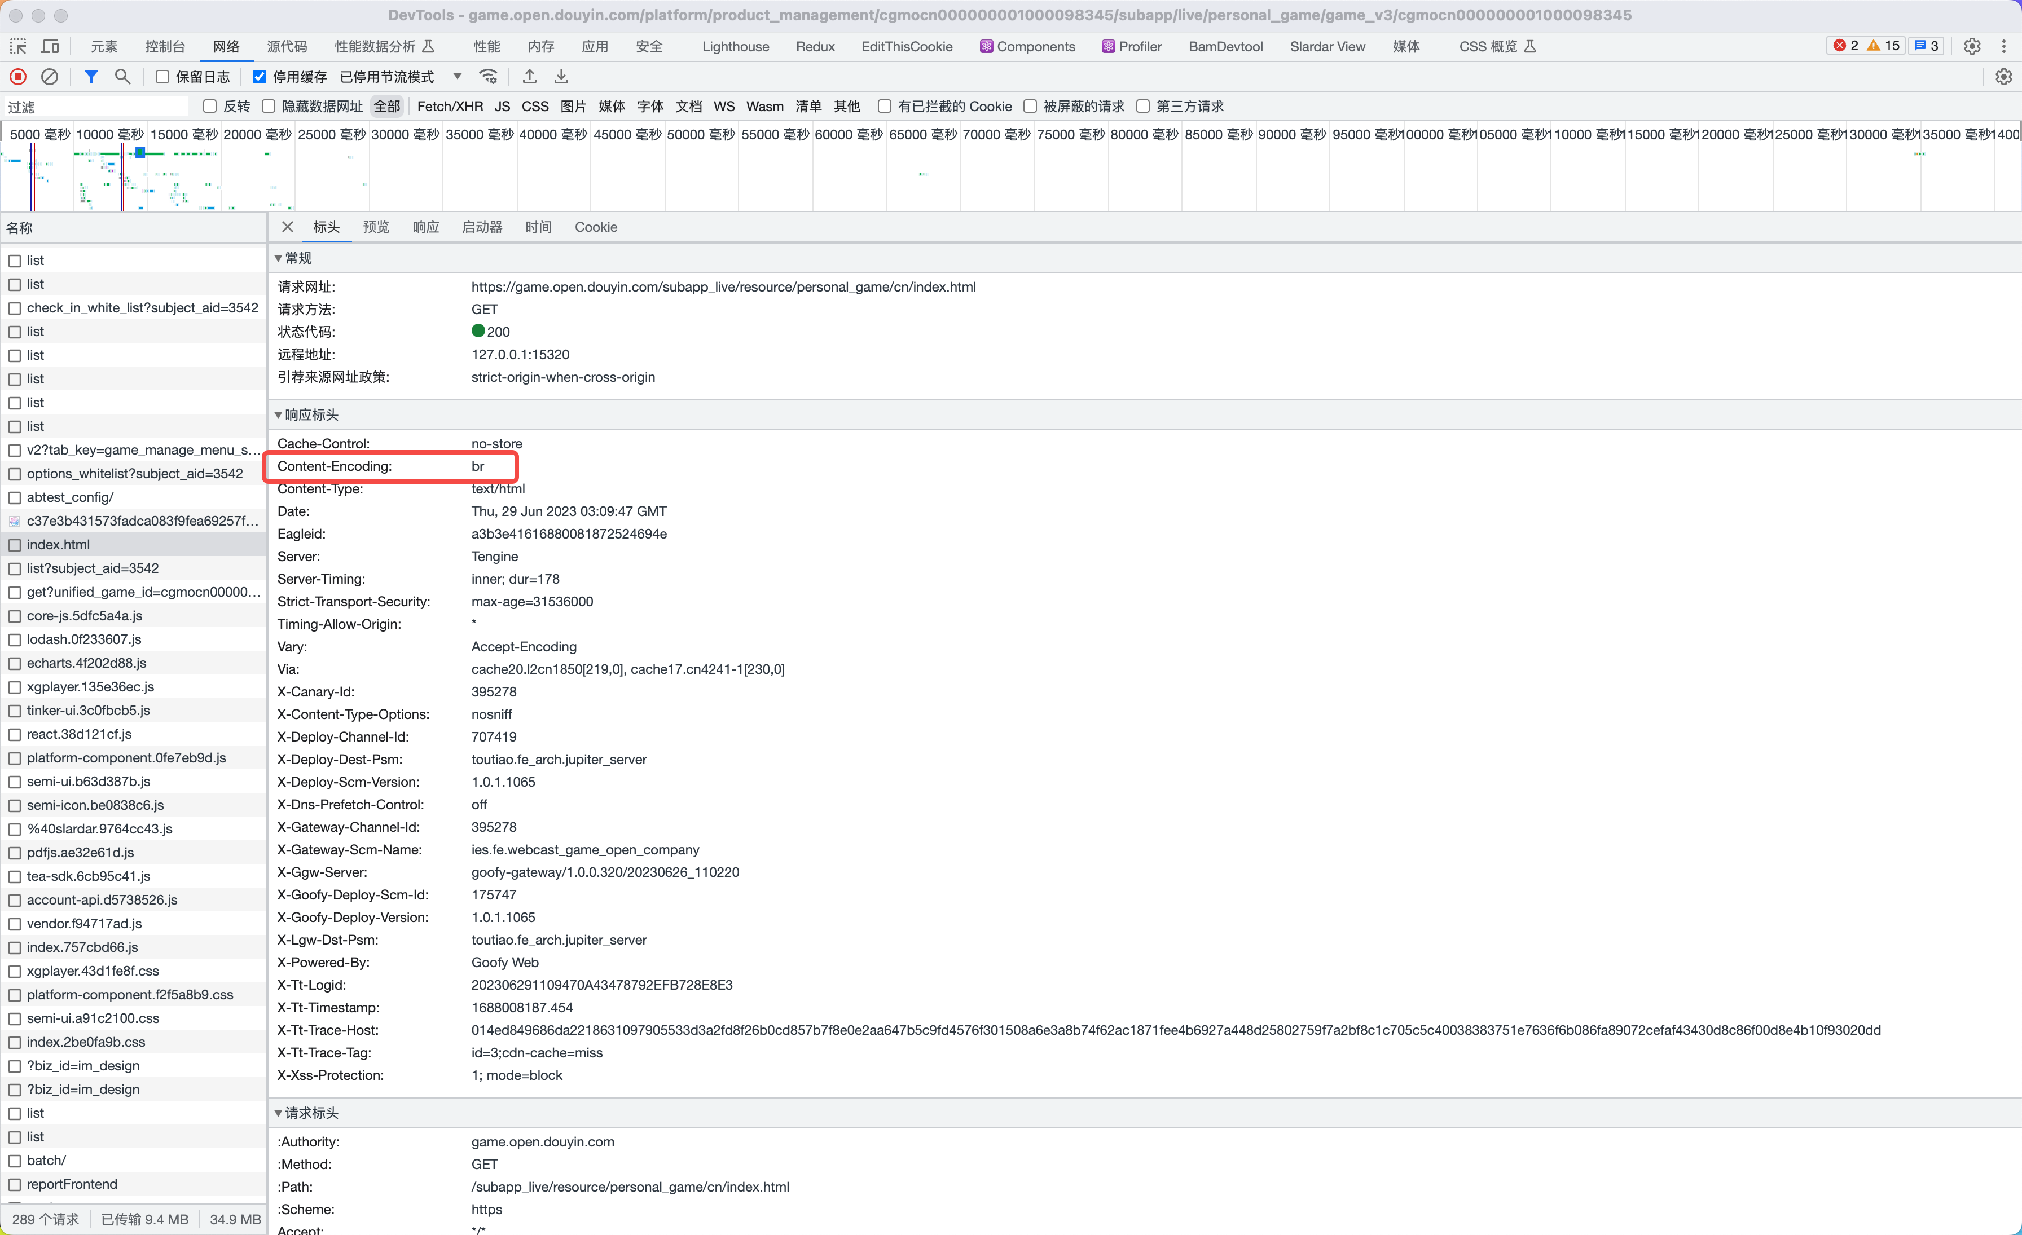

**dns-prefetch（done）**

|  |
| --- |
| [eden performance.dnsPrefetch](https://eden.bytedance.net/solution/web/configuration/webpack/abilities#performancednsprefetch) |

|  |
| --- |
| TypeScript const baseDNSPrefetchHost = [  '//lf-cdn-tos.bytescm.com/',  '//lf1-cdn-tos.bytescm.com/',  '//lf3-cdn-tos.bytescm.com/',  '//lf6-cdn-tos.bytescm.com/',  '//p3-gameunion-sign.dailygn.com/',  '//p6-gameunion-sign.dailygn.com/',  '//p9-gameunion-sign.dailygn.com/',  '//sf16-short-va.bytedapm.com/',  '//mcs.zijieapi.com/',  '//mon.zijieapi.com/',  '//api.feelgood.cn/', ];  /**  *  * @param {*} hosts 添加 dns-prefetch host  * @param {*} cover 是否覆盖 baseDNSPrefetchHost  * @returns  */ const genDNSPrefetch = (hosts, cover = false) => {  let tmp = cover ? [] : [...baseDNSPrefetchHost];  tmp = Array.isArray(hosts) ? tmp.concat(hosts) : tmp;  return tmp.map(href => ({  href,  })); };  performance: {  dnsPrefetch: genDNSPrefetch(), }, |

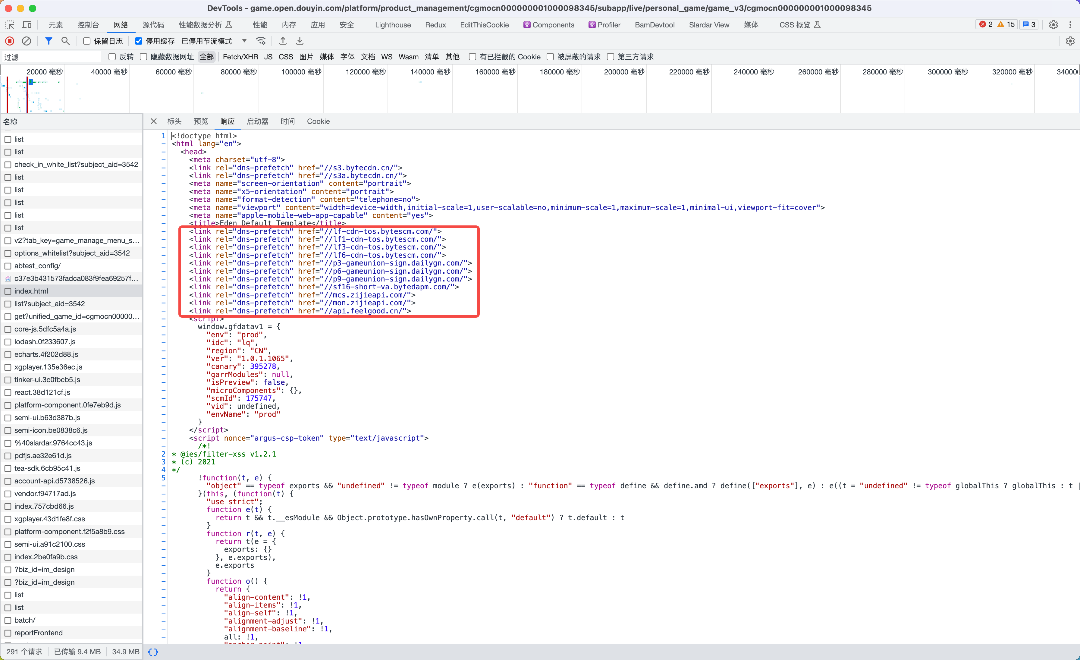

**~~preconnect，暂不需要~~**

**打包优化**

**拆/合包（done）**

|  |
| --- |
| [eden 拆包](https://eden.bytedance.net/solution/web/guide/advance/split-chunks)  [performance.chunkSplit](https://eden.bytedance.net/solution/web/configuration/webpack/abilities#performancechunksplit) |

**拆包策略**

1. 尽可能按需加载 -- 减少首屏包体积
2. 路由按需加载，通过 [loadable](https://loadable-components.com/) 实现。存放于目录 /common

|  |
| --- |
| 加上 webpackChunkName，提高缓存使用率。通过 babel 插件实现，不需要手动填写。 |

|  |
| --- |
| TypeScript // 例如  const GameLiveList = loadable(  () => import(/* webpackChunkName: "GameLiveList", webpackPrefetch: true */ '../pages/GameLiveList') ); |

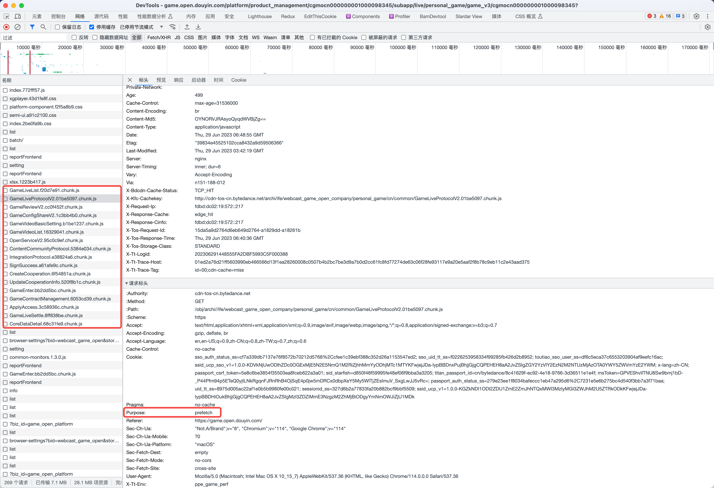

1. 配置生成的路由 chunkName

|  |
| --- |
| TypeScript output: {  chunkFilename: 'common/[name].[chunkhash:8].chunk.js', } |

1. 根据动态 import 路径，自动生成 chunkName

|  |
| --- |
| TypeScript  // babel 插件 function getChunkName(filename) {  return filename.replace(/^\.\.\//, '').replace(/(\.)*\//g, '-'); }  function hasComment(comment) {  return comment && comment.value.replace(/\*+/g, '').trim().startsWith('webpackChunkName'); }  module.exports = function ({ types: t }) {  return {  visitor: {  CallExpression(path) {  if (path.node.callee.type !== 'Import') {  return;  }   const [arg] = path.node.arguments;  const [comment] = arg.leadingComments || [];   if (!hasComment(comment)) {  t.addComment(arg, 'leading', `webpackChunkName: '${getChunkName(arg.value)}'`);  }  },  },  }; }; |

1. 依赖包的按需加载 async chunk，通过 [cacheGroups](https://webpack.js.org/plugins/split-chunks-plugin/#splitchunkscachegroups) 实现，保证 group 优先级最高。存放于目录 /async。
2. 通过分析入口文件，手动动态 import 实现按需加载，通过 [loadable](https://loadable-components.com/) 实现。
3. 合理拆包 -- 减少最大包体积
4. 将较大的依赖包单独打包 split chunk，后续也可抽离公共包，通过 [cacheGroups](https://webpack.js.org/plugins/split-chunks-plugin/#splitchunkscachegroups) 实现，优先级低于 async chunk，但高于其他 chunk。存放于目录 /chunk。
5. 其余的依赖包打包到一起作为 vendor chunk。
6. 入口文件通过 webpack 自动拆包，拆解为 index chunk，以及部分按需加载的 chunk。
7. 抽离公共依赖包。

|  |
| --- |
| TypeScript {  // webpack 拆包参数  chunks: 'all',  minRemainingSize: 0,  minSize: 20000,  minChunks: 1,  maxAsyncRequests: 30,  maxInitialRequests: 30,  enforceSizeThreshold: 50000,   // 自定义拆包规则  cacheGroups: {  defaultVendors: {  test: /[\\/]node_modules[\\/]/,  priority: -10,  reuseExistingChunk: true,  name: 'vendor',  filename: '[name].[contenthash:8].js',  },  default: {  minChunks: 2,  priority: -20,  reuseExistingChunk: true,  filename: '[name].[contenthash:8].js',  },  ...moduleNames.reduce((groups, moduleName, idx) => {  return {  // async chunk，按需加载  [`async-${moduleName}`]: {  chunks: 'async',  test: new RegExp(`[\/]node_modules[\/][^\/]*${moduleName}`), // 只识别 node_modules 下一级目录名称，保证匹配精确  // test: new RegExp(moduleName),  priority: 100 + idx,  reuseExistingChunk: false,  name: `async/${moduleName}`,  filename: '[name].[contenthash:8].js',  },  // split chunk，defer 加载  [`${moduleName}`]: {  test: new RegExp(`[\/]node_modules[\/][^\/]*${moduleName}`), // 只识别 node_modules 下一级目录名称，保证匹配精确  // test: new RegExp(moduleName),  priority: 10 + idx,  reuseExistingChunk: true,  name: `chunk/${moduleName}`,  filename: '[name].[contenthash:8].js',  },  };  }),  }, } |

**拆包效果**

* 首屏只会加载 index chunk、vendor chunk，以及 /chunk 目录下的 split chunk。chunk 脚本直接嵌入 html 文件，defer 加载。
* 路由 chunk、async chunk按需加载。

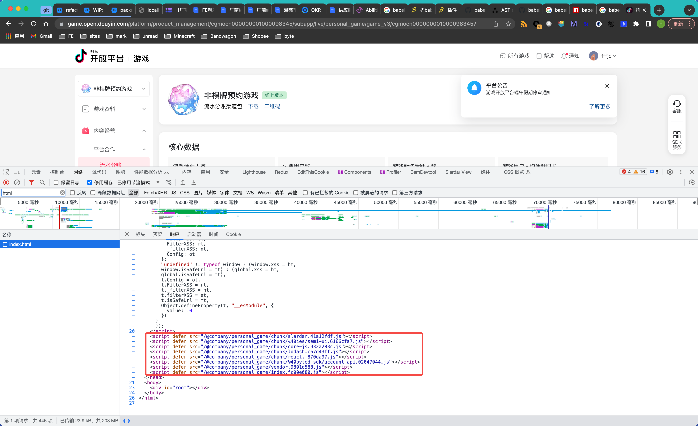

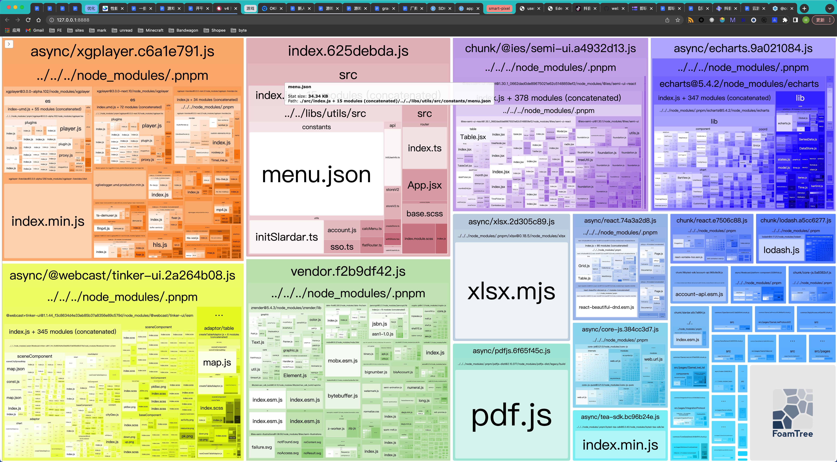

**按需加载**

**依赖包按需加载处理**

**semi**

v1 不支持按需加载，需升级 v2

**semi-icon (done)**

**v1**

|  |
| --- |
| [semi-icon 按需加载](https://semi-1x.bytedance.net/zh-CN/basic/icon#%E6%8C%89%E9%9C%80%E5%8A%A0%E8%BD%BD) |

1. 增加配置 iconLazyLoad

|  |
| --- |
| TypeScript semi: {  iconLazyLoad: true, } |

1. 所有 <Icon type="xxx" />需要显式引用 xxxsvg.id。icon 来源有两个：

* semi 内置 icon：@ies/semi-icons/xxx.svg
* 自定义 icon：@webcast_game_open/components/common/icons/xxx.svg

|  |
| --- |
| TypeScript // 使用例子  import IconClose from '@ies/semi-icons/semi-icons-close.svg'; import IconExport from '@webcast_game_open/components/common/icons/icon_export.svg';  <Icon type={IconClose.id} /> <Icon type={IconExport.id} iconSize={12} /> |

|  |
| --- |
| 开启 iconLazyLoad 后，因为依赖的 Tinker 组件使用 Icon 方式导致无法显示，因此需要额外处理，详见 [【WIP 前端技术方案】semi-icons 懒加载优化处理](https://bytedance.feishu.cn/wiki/JapcwwdD2i7lPNkGZgzcCYNPnuf) |

**v2**

1. 使用内置 icon

|  |
| --- |
| TypeScript import { IconXXX } from '@douyinfe/semi-icons';  <IconXXX /> |

1. 使用自定义 svg，通过 @svgr/webpack 将 svg 转为 react 组件

|  |
| --- |
| TypeScript import Icon from '@douyinfe/semi-icons'; import MySvg from '@webcast_game_open/components/common/icons/my.svg'  <Icon svg={<MySvg />} /> |

**lodash (done)**

lodash 全部替换为 lodash-es

**手动动态 import**

biz-component 按需加载处理

**删除无用依赖**

删除无用的其他子应用依赖 (done)

|  |
| --- |
| TypeScript "@company/login": "workspace:^1.0.0", "@company/main_app": "workspace:^1.0.0", "@company/workbench": "workspace:^1.0.0", |

**依赖包重复引用**

**配置 webpack alias**

* echarts

|  |
| --- |
| TypeScript alias: {  echarts: path.resolve(__dirname, './node_modules/@webcast_game_open/bizcomponents/node_modules/echarts'), }, |

业务代码有v4、v5的混用，后续统一为v5

v4 -> v5: https://echarts.apache.org/handbook/zh/basics/release-note/v5-upgrade-guide/

* Tinker

子应用升级到 biz-component 版本

* xgplayer

@webcast/platform-components 依赖 3.0.0-next.10，后续下掉 @webcast/platform-components

**配置 overrides，配置在根目录，所有子应用生效。**

|  |
| --- |
| 前期先通过 alias 单独处理每个子应用，完成后再切 overrides |

|  |
| --- |
| TypeScript "pnpm": {  "overrides": {  "echarts": ">=5.0.0"  } } |

**CDN**

// TODO：子应用共享依赖

**Tree shaking**

**分离开发数据**

* menu.json（34KB），看能否提取到配置平台 @Dahai Long
* Mock 数据

**资源加载优化**

**资源预处理**

// TODO

* preload
* prefetch
* prerender

**业务优化**

// TODO

**耗时拆分**

* CSS 加载阻塞
* 串行接口调用
* 必要初始化提前
* 接口缓存

**子应用优化效果**

|  |  |  |  |  |  |  |  |  |
| --- | --- | --- | --- | --- | --- | --- | --- | --- |
| 子应用 | 打包结果(前) | 打包结果(后) | 首屏包体积(前)(KB) | 首屏包体积(后)(KB) | 首屏包体积减少(KB) | MFFP-PCT75(前)(ms)  通过对 6.26-6.30 和 7.3-7.7 两周的 11:00-20:00 求平均 | MFFP-PCT75(后)(ms) | 首屏加载耗时减少(ms) |
| account_info |  |  | 476.79 | 365.8 | 110.99 (23.28%) | 804.25 |  |  |
| anchor_manage |  |  | 1125.57 | 674.13 | 674.14 (59.89%) | 1166 |  |  |
| bussiness_manage |  |  | 667.98 | 430.74 | 237.24 (35.52%) | 745.62 |  |  |
| community_operation |  |  | 1252.77 | 518.41 | 734.36 (58.62%) | 1141.38 |  |  |
| content_strategy |  |  | 1949.07 | 542.31 | 1406.76 (72.18%) | 1747 |  |  |
| creator_recruitment |  |  | 2333.67 | 503.87 | 1829.80 (78.41%) | 2072.25 |  |  |
| data_center |  |  | 2217.83 | 531.56 | 1686.27 (76.03%) | 2279.16 |  |  |
| deep_operation |  |  | 1513.14 | 211.68 | 1301.46 (86.01%) |  |  |  |
| game_component |  |  | 2587.96 | 472.21 | 2115.75 (81.75%) | 1638.44 |  |  |
| game_evaluation |  |  | 614.08 | 438.8 | 175.28 (28.54%) | 1030.75 |  |  |
| game_operation |  |  | 1742.21 | 454.26 | 1287.95 (73.93%) | 1458.22 |  |  |
| game_strategy |  |  | 1871.65 | 474.09 | 1397.56 (74.67%) | 1530.38 |  |  |
| management_data |  |  | 676.31 | 464.72 | 211.59 (31.29%) | 956 |  |  |
| marketing_center |  |  | 1704.06 | 533.44 | 1170.62 (68.7%) | 1427.38 |  |  |
| personal_game |  |  | 2099.65 | 550.56 | 1549.09 (73.78%) | 1548.98 |  |  |
| platform_cooperation |  |  | 569.5 | 451.46 | 118.04 (20.73%) | 1051.25 |  |  |
| sdk_access |  |  | 561.07 | 422.28 | 138.79 (24.74%) | 725.43 |  |  |
| 总计 |  |  | 24260.39 | 8040.32 | 16220.07 (66.86) | 21322.49 |  |  |

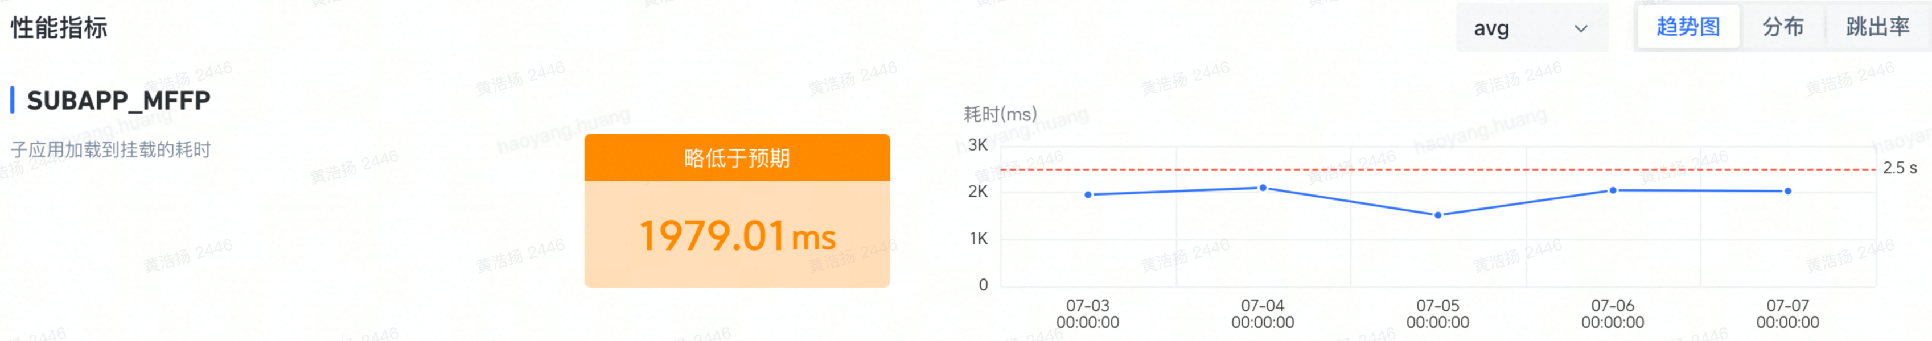

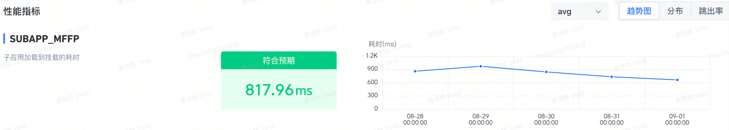

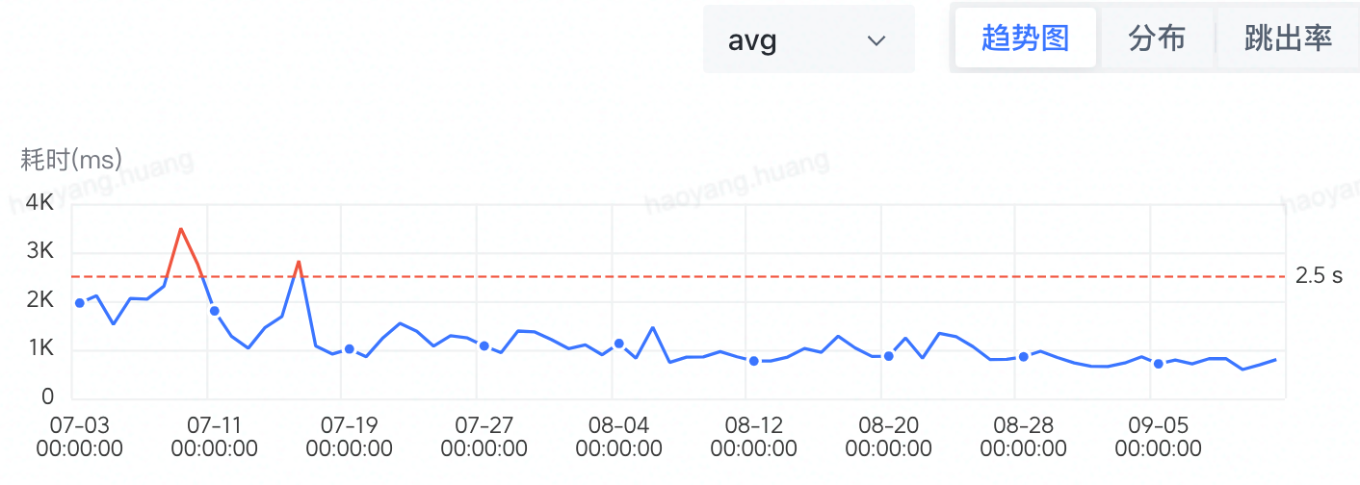

|  |
| --- |
| * **总首屏包体积减少 66.8%** * **总打包体积从 127M -> 90M，减少了 29%** * **总首屏耗时从 1980ms -> 900ms，减少了 54.5%** |

**参考**

[性能优化](https://bytedance.feishu.cn/docx/Ib1zd0K26okbYXxCG9Wc4z4inKb)